How to install and activate packet tracer in Windows
Download the latest version or the version of Packet Tracer that you want to install on the Windows system. You can download the installer file of Packet Tracer from the following web page.
Download Packet Tracer 8.0.0 and all Previous Versions (computernetworkingnotes.com)
Double click the setup or installer file of Packet Tracer. Depending on UAC (User Access Control) setting, Windows may prompt to confirm the installation. If it prompts, click the Yes button to confirm the installation. After confirmation, the installation process starts in a graphical wizard.
The first screen of the installation wizard presents the license agreement. Select the "I accept the agreement" option and click the "Next" button.
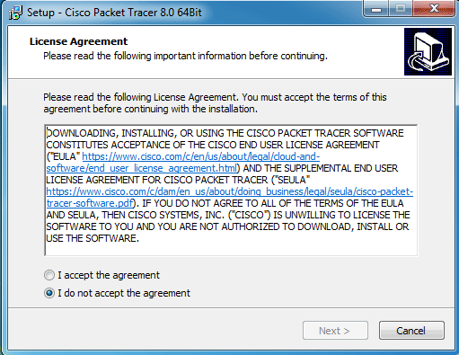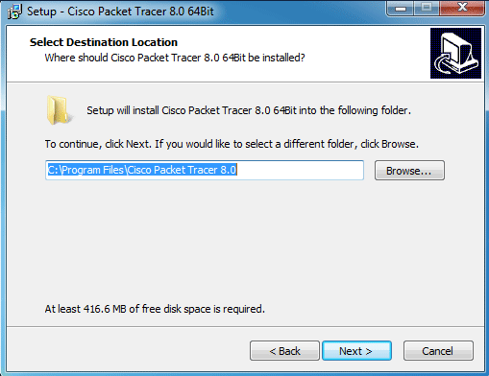
The next screen provides an option to customize the installation directory. By default, Packet Tracer is installed in the "Program File" folder of the Windows partition. If you want to install Packet Tracer in another folder, click the Browse button and select the folder in which you want to install Packet Tracer.
Make your choice and click the Next button to continue the installation.
A shortcut-link name is used to launch an application from the Start menu. By default, the wizard uses the name "Cisco Packet Tracer" for both the folder-name and the shortcut-link name.
Keep default selections and click the Next button. The next screen allows us to create two more shortcut links to launch the Packet Tracer.
Create a desktop icon: - This option creates a shortcut link on the Desktop.
Create a quick launch icon: - This option creates a shortcut link in the Quick-Launch bar.
Make your choice and click the Next button.
The next screen provides a summary of selections. If you want to change an option, use the Back button to get that option. To start the installation with currently selected options, click the Install button.
The wizard displays the real-time progress of the installation.
If the installation is successful, this screen shows an option to launch the Packet Tracer. If you keep this option selected, the packet tracer starts when the wizard is closed.
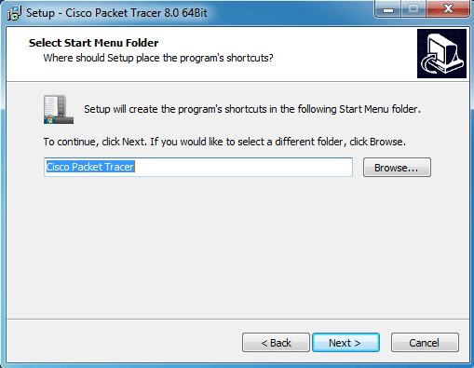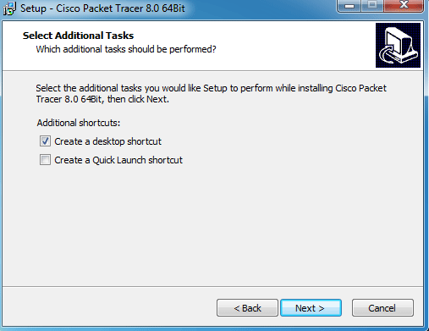
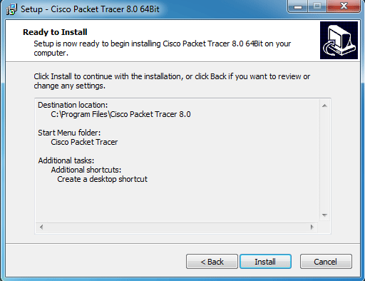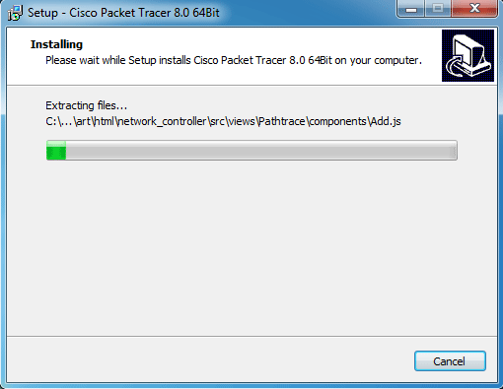
Click the Finish button to close the wizard.
When Packet Tracer starts the first time, it asks the user to select the mode in which it should start. Multi-user mode allows multiple users to work simultaneously. If you don't want to share or exchange your packet tracer instance, click the No button.
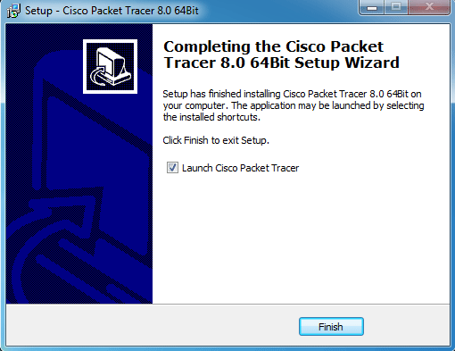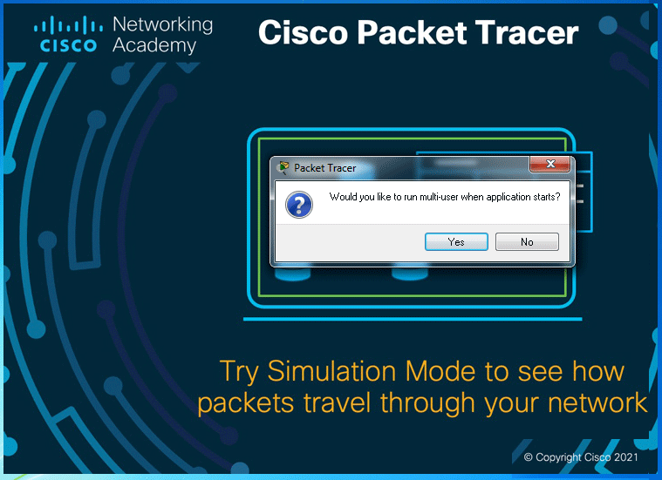
Since version 7.0.0, Packet Tracer can only be used after login. When you start Packet Tracer, it presents a login box. If the system is not connected to the Internet, you can use the Guest account to access Packet Tracer.

To use a guest account, click the Guest login button on startup. The guest account offers limited features. This account allows you to save only 3 practice labs.
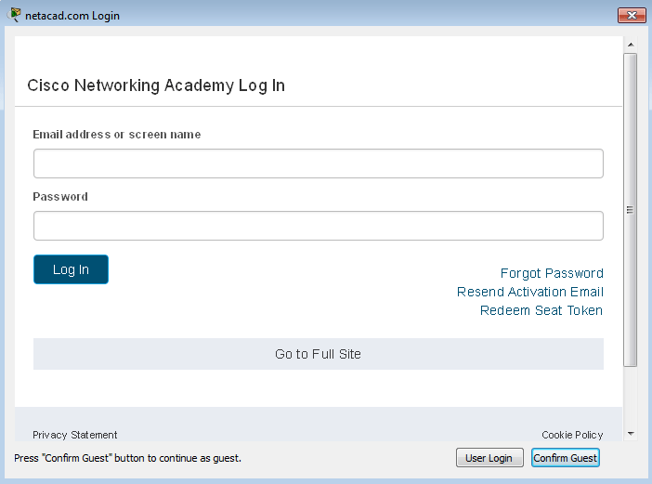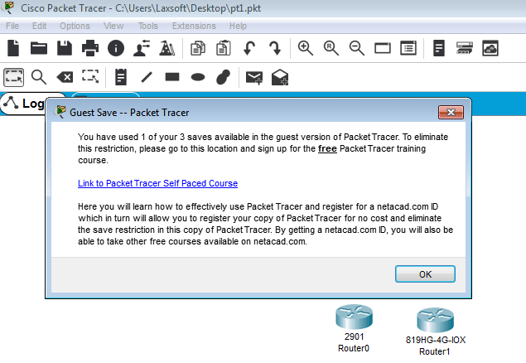
To remove this restriction, you must log in to Packet Tracer from a Cisco Academy account. To create a free Cisco Academy account, visit the following web page.
https://www.netacad.com/courses/packet-tracer/introduction-packet-tracer
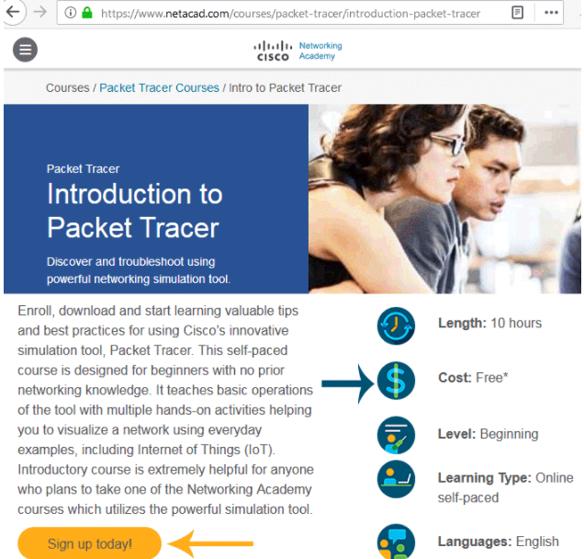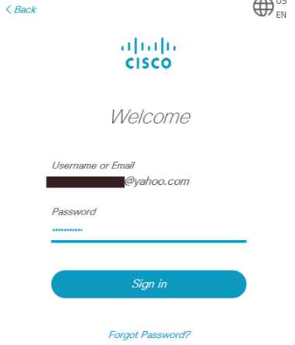
Visit the above web-page and create a free user account and use that user account to login to Packet Tracer. Upon successful authentication, Packet Tracer will be activated and all restrictions will be removed.
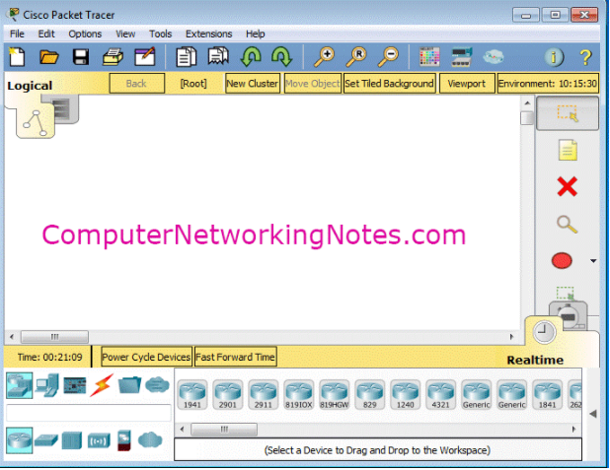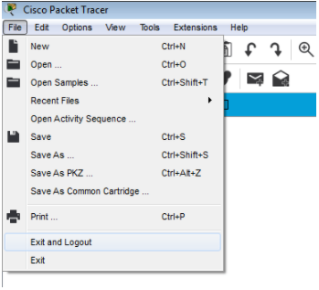
If you want to logout from Packet Tracer, click the File menu item and click the "Exit and Logout" option from the sub-menu options.
Commands for Basic Router Configuration
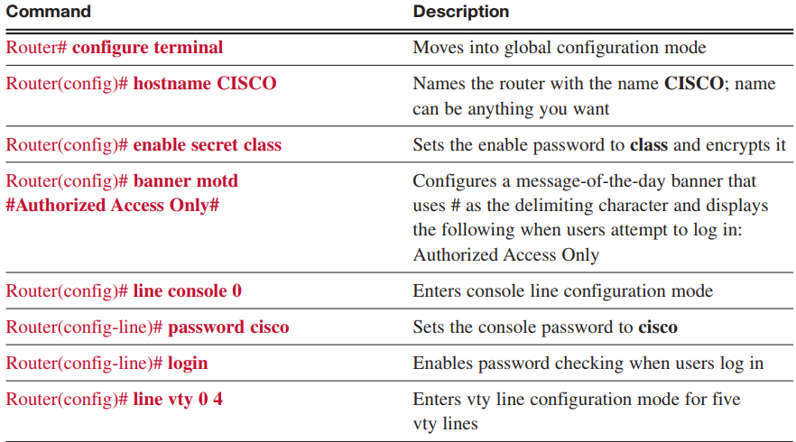
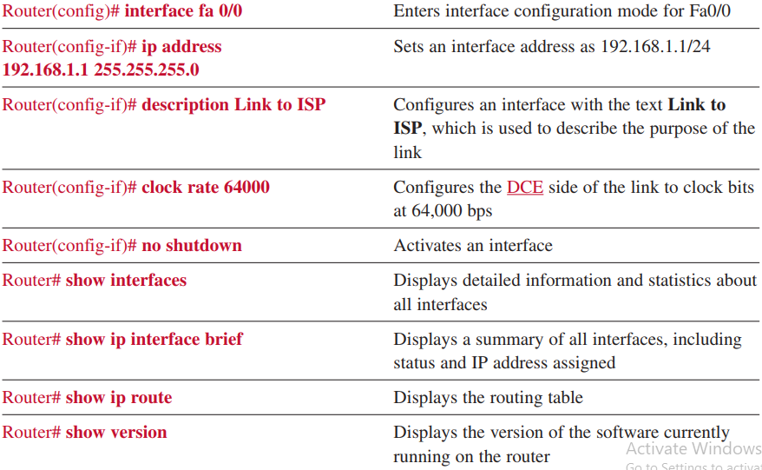
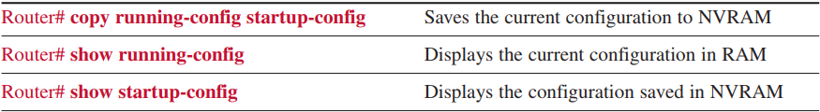
Packet Tracer Beginner Tutorial Part 1
1. Go to end devices
2. Drag out a generic computer
3. Go to switches
4. Drag out the 2960 switch
5. Then go back to end devices
6. Drag out a generic server
7. Go to connections, look for straight through cable
8. Click the PC and connect to the Ethernet port, then click the switch and connect
the cable to the first Ethernet port
9. Using the same cable connect it to the Ethernet port on the server and the next
available port on the switch
10. Name the server 192.168.1.254
11. Name the PC 192.168.1.100
12. Open the server and go to config, and click on FastEthernet
13. In the IP Address field type 192.168.1.254 and click the Subnet Mask to get that
number too
14. Close out of the Server
15. Open the PC and go to config, and click on FastEthernet
16. In the IP Address field type 192.168.1.100 and click the Subnet Mask to get that
number too
17. Click on desktop and run a Command Prompt
18. Type ping 192.168.1.254
19. Open the Server
20. Under config, click FTP
21. Create a new user, with the ability to Read and Write
22. Username – student Password – student
23. Open the PC
24. Under Desktop, open the Web Browser
25. Type 192.168.1.254 in the URL box
26. Close the Web Browser
27. Open a Command Prompt
28. Type ftp 192.168.1.254
29. Login Username – student Password – student
30. Type quit to exit ftp
31. Close out of the PC and you are done

1.1.4.5: Packet Tracer – Configuring and Verifying a Small Network
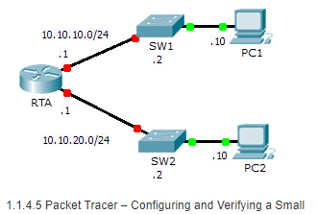
Addressing Table
Device | Interface | IP Address | Subnet Mask | Default Gateway
- RTA | - G0/0 | - 10.10.10.1 | - 255.255.255.0 | - N/A
 | G0/1 | 10.10.20.1 | 255.255.255.0 | N/A
SW1 | VLAN1 | 10.10.10.2 | 255.255.255.0 | - 10.10.10.1
- SW2 | - VLAN1 | - 10.10.20.2 | - 255.255.255.0 | - 10.10.20.1
- PC1 | - NIC | - 10.10.10.10 | - 255.255.255.0 | - 10.10.10.1
- PC2 | - NIC | - 10.10.20.10 | - 255.255.255.0 | - 10.10.20.1

Objectives
Part 1: Configure Devices and Verify Connectivity
Part 2: Gather Information with Show Commands

Background
In this activity, you will configure RTA with basic settings, including IP addressing. You will also configure SW1 for remote management and configure the PCs. Once you have successfully verified connectivity, you will use show commands to gather information about the network.
Note: The user EXEC password is cisco. The privileged EXEC password is class.

Part 1: Configure Devices and Verify Connectivity

Step 1: Apply basic configurations to RTA.
- Using the following information and the Addressing Table, configure RTA:
  - Hostname and banner
  - Line passwords set to cisco; encrypted password set to class
  - IP addressing and descriptions on LAN interfaces
- Save the configuration.

Step 2: Configure addressing on PC1 and PC2.
- Using the Addressing Table, configure IP addressing for PC1 and PC2.
- Test connectivity between PC1 and PC2. Troubleshoot as necessary.

Step 3: Configure SW1 for remote management.
- Using the Addressing Table, configure the management interface for SW1.
- Configure the default gateway address.
- Save the configuration.

Part 2: Gather Information with Show Commands

Step 1: Gather information from show interface command output.
Issue each of the following commands and then answer the related questions:
show ip interface brief
show interfaces
show ip interface
Which commands display the status of the port? show ip interface brief, show interfaces, show ip interface
Which command shows only the IP address (no subnet mask or prefix)? show ip interface brief
Which command displays the description configured on the interface? show interfaces
Which command displays the IP broadcast address? show ip interface
Which command displays the MAC address of the interface? show interface

Step 2: Gather information from show ip route command output.
Issue each of the following commands and then answer the related questions:
show ip route
show ip route connected
How many networks are known by the router based on the output of the show ip route command? 2 – 10.10.10.0/24 & 10.10.20.0/24
What does the L at the beginning of the lines within the routing table represent? Local connection
What does the /32 prefix listed in the route table indicate? The host address of the interface

Step 3: Gather information after an interface state is changed.
- On RTA, shut down the Gigabit Ethernet 0/0 interface and issue the show ip route command. How many networks are displayed in the routing table now? 1 – 10.10.20.0/24
- Attempt to ping PC1. Was the ping successful? No
- Issue the show ip interface brief command. What is the status of the Gigabit Ethernet 0/0 interface? administratively down
- Reactivate the Gigabit Ethernet 0/0 interface. Issue the show ip route command. Did the routing table repopulate? Yes
- What can be inferred about the interface status of routes that appear in the routing table? Interfaces must be active in order to be listed in the routing table.

